Carousel

Slide 1:

1. **"Love for all living beings is the noblest quality of man."**  
   - Charles Darwin

Emotional image with cat and man  
Donate & Adopt link  
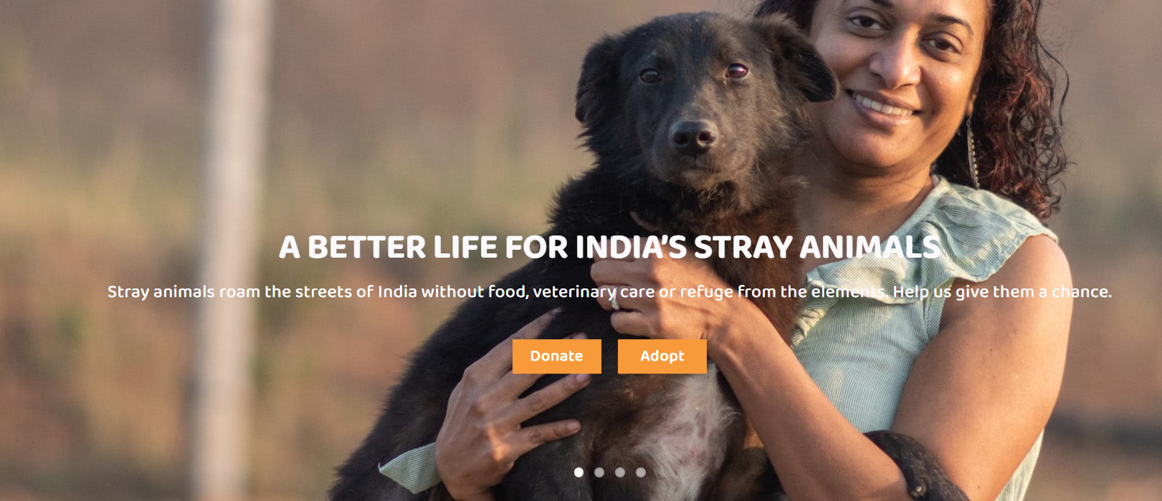

Slide 2:  
Mission to improve stray lives and make the streets of kashmir stray-friendly  
Volunteer link  
  
Slide 3:  
5 years & counting…  
Support us  
Insta & fb link

About Us

KAWF is a registered (Reg. No. 2354168) Not-for-Profit self-funded, volunteer based organization in Kashmir Valley, which aims to help and improve the life of abused & starving strays of the valley. It is the result of the efforts of three kashmiri girls who have been actively working and contributing in the Animal Rescue Domain for the past 15 years.

From a handful of animal lovers to a significant volunteer base, KAWF has come a long way. Our volunteers and those who work with us are 20-40 year old who are empathetic enough and have realized the importance of having a consolidated welfare system for animals in the valley.

Challenges:

1. Abhorrent attitude towards stray animals; especially dogs who are tagged as dirty and impure
2. Lack of awareness programs at educational or social levels
3. Absence of ambulances and mobile para-vet system for on-spot treatments

Co-Founders

1. Sanna Bandey
   1. She is also a part of Lucknow Animal Welfare groups, and has worked in different geographies participating in rescue, rehabilitation and adoption.
2. Asma Noor Sheikh
   1. Has been actively involved with animal rescue and welfare for the past decade, and works with animal rescue groups in Delhi-NCR
3. Nighat Lone
   1. She has been instrumental in shaping up the preliminary animal welfare system in the valley by her individual efforts since a young age

Adopt  
*"You can't save all the dogs & cats in the world, but you can save one dog's (or cat’s) whole world!"* and have yourself a best friend!

Volunteer

We need as many hands on board as possible, and you will also get a shiny new certificate! The rescues are many and people, few. Join us, to spread the love.

Donate  
We rely solely on donations - monetary or otherwise - for our work. Help us achieve our goals and check out our wishlist as well.

Blog Posts

**Help us achieve our goals:**

Animals deserve as much help and support as humans do. We have some goals focused on this very thought.

1. A lifetime sanctuary for animals with permanent disabilites
2. Fully operational diagnostic center and dispensary
3. A surgical unit for immediate and on-going surgeries
4. A mobile treatment unit for on-spot medical attention
5. Ambulances
6. Training programs for paravets and other non-technical staff
7. Awareness programs in schools, colleges and offices
8. Collaboration with print, digital and analogue media partners for running awareness and information programs
9. Establishment of a quick response team for cases reported by locals
10. A quick response helpline - experienced volunteers can give online support and guide people who want to help animals in need.

We seek to ultimately provide the animals in Kashmir with the same treatment and care as humans receive, but none of this will be possible without your help.

Click here, to support us. (link to donations)

**Kashmir Animal Welfare Network & Partners**

KAWFCares works very hard to ensure that at least a few of the many animals in Kashmir receive timely help and treatment. Unfortunately, due to the escalating number of rescues we receive each day, and the lack of resources or people who can help us out, we might be a little delayed in responding to the rescue calls or messages from all of you out there who want to help. Nevertheless, we strive to respond back when we are free and so do leave a message - your name and contact, details or the rescue case - preferably with photos - and the exact location that we need to reach.

We will try our best to be as quick as possible in helping you out.

If we don’t respond as quickly as the situation desires, then feel free to contact our partners who are all very enthusiastically involved in animal rescues as well. You can contact them, and if they don’t respond either they are also probably busy. Leave a message with all the details as previously stated and stay strong.

1. Stray world [STRAY_WORLD (@strayworld._) • Instagram photos and videos](https://www.instagram.com/p/Cx8FAMgyTj-/)
2. ARK (No rescues as of now) [Animal Rescue kashmir (ARK) ©️ (@animal_rescue_kashmir) • Instagram photos and videos](https://www.instagram.com/animal_rescue_kashmir/)
3. Animal aid Kashmir <https://www.instagram.com/animal_aid_kashmir/?hl=en>
4. ASR [Animal Salvation & Relief - Kashmir (@asrkashmir) • Instagram photos and videos](https://www.instagram.com/asrkashmir/)
5. Hope [Hope Baramulla (@_hopeforstrays) • Instagram photos and videos](https://www.instagram.com/_hopeforstrays/followers/mutualOnly)
6. J&K Animal Care Center
7. [Animal protectors baramulla (@animal_protectors_baramulla) • Instagram photos and videos](https://www.instagram.com/animal_protectors_baramulla/)
8. Tales of pawprints [Tales of paw prints (@tales_of_pawprints) • Instagram photos and videos](https://www.instagram.com/tales_of_pawprints/)

And many volunteers

Refer to these emergency first-aid guidelines for animals:

List of Veterinary centers in Srinagar area:

<https://maps.app.goo.gl/xJBkH6TBDbawKGei9>

**Why Donate?**

Animal Rescue becomes a difficult task when there is passion in the work being done, but with no means of sustenance. This is the case in most animal rescue centers, especially in Kashmir.

Almost all centers are volunteer-based, non-profit organizations. Most of the animals they rescue are terribly injured, wrought with maggots, living in pathetic conditions without water or food. Can we even say that they are “living”, when the situation is so dire?

To fulfill these demands the centers need:

food - at least twice a day for each animal at the shelter

medications - which are expensive and scarcely in many areas of Kashmir,

special items - like baby formula for newborns,

ambulances for traveling to rescue the animals,

space - for making a shelter, which they scarcely have,

the list is endless.

And the source of money? Their own pockets.

A major issue the animal centers face hence becomes the dire lack of funds. This stems from the lack of awareness in the region about the need and importance of Animal Rescue. 01

Most centers resort to paying for the towering bills themselves. They get rescues, care for them in the best possible way, pay an immense amount, get more rescues and this cycle goes on till one day, they can’t do this anymore.

Donations are paramount for running animal rescue centers.

They need help, so they can help. So the maggot infested dog, the cat who got badly bitten, the horse that lost its leg, the pup who got abandoned, can all get the help they deserve.

[Nighat Lone, Co-Founder and Trustee, Kashmir Animal Welfare Foundation (KAWF Cares), highlights uphill battle for animal welfare in Kashmir - JK MONITOR](https://jkmonitor.org/categories/nighat-lone-founder-and-the-chairperson-of-kashmir-animal-welfare-foundation-kawf-cares-highlights-uphill-battle-for-animal-welfare-in-kashmir)

Our Wishlist

We accept donations in all forms and not just monetary. We require these items on a daily basis and receiving these directly can help us immensely to achieve our goals.

1. Cleaning Supplies
   1. Lizol, phenyl
2. Antiseptic
   1. Dettol, Savlon
3. Food Supplies
   1. Dog Food, Cat Food, Rice, Flour, Egg trays, Milk Formula for Puppies
4. Medical Supplies
   1. Cotton Rolls, Bandages, Syringes (5 ml & 3ml), Betadine (liquid), Ivermectin
5. Pet Products
   1. Collars, leashes, shampoos, toys
6. Old Furniture
   1. Office or home use, tables, pillows, etc.
7. Old Clothes
   1. Woollens, towels, bedsheets

In the short run, we aim to help as many animals as we can through immediate rescues, on-spot treatments, etc. In the long run we need to establish a standardized system where these processes can be made efficient and easier, not only for us but also for those who seek help.

Together, we can foster an environment of compassion and ensure an aware audience. Check out our long term goals, here. (link to the goals blog)

Contact Us:

Instagram:  
Facebook:  
Mail:

Mobile:

1. **"We don't have two hearts, one for animals and one for humans ; we have one heart or we don't have any."** (Alphonse de Lamartine)
2. **"Compassion for animals is intimately associated with goodness of character, and it may be confidently asserted that he who is cruel to animals cannot be a good man."** (Arthur Schopenhauer)
3. **"Treat your pet like you can live with reversed roles in the next life without any problems."** (Pascal Lachenmeier)
4. **"Love for all living beings is the noblest quality of man."** (Charles Darwin)

Another Blog Idea:  
<https://www.pashudhanpraharee.com/10-laws-rights-to-protect-stray-animals-in-india-that-every-animal-lover-should-be-aware-of/>   
<https://www.iitk.ac.in/animalwelfare/data/Animal-Protection-Law-Summary-by-AWBI.pdf>   
Stray animals, including dogs and cats, are often at higher risk for various medical conditions due to exposure to harsh environments, lack of proper nutrition, limited access to veterinary care, and high levels of stress. Mange is a common medical condition seen in stray animals, especially dogs. Mange is a skin disease caused by mites, and it can manifest in different forms, including sarcoptic mange and demodectic mange. Here are some common medical conditions, including mange, that stray animals may experience:

1. **Mange (Sarcoptic and Demodectic)**:

- **Sarcoptic Mange**: Caused by Sarcoptes scabiei mites, sarcoptic mange leads to intense itching, hair loss, skin redness, and crusty lesions. It can spread to other animals and humans.

- **Demodectic Mange**: Caused by Demodex mites, demodectic mange causes localized or generalized hair loss, skin inflammation, and sometimes secondary bacterial infections.

2. **Skin Infections**:

- Stray animals are susceptible to various skin infections due to exposure to unclean and contaminated environments. These infections can cause skin lesions, redness, itchiness, and discomfort.

3. **Parasitic Infestations**:

- Stray animals often suffer from a heavy burden of internal and external parasites such as fleas, ticks, worms (intestinal parasites), and heartworms. These parasites can cause various health issues, including anemia, malnutrition, and gastrointestinal problems.

4. **Malnutrition and Starvation**:

- Stray animals often struggle to find adequate food, leading to malnutrition, weakness, emaciation, and compromised immune systems.

5. **Injuries and Trauma**:

- Stray animals are exposed to accidents, fights, and injuries due to lack of supervision, traffic hazards, and conflicts with other animals. These injuries can range from minor cuts and bruises to severe fractures and wounds.

6. **Respiratory Infections**:

- Stray animals are exposed to adverse weather conditions, pollution, and overcrowded living conditions, making them susceptible to respiratory infections such as pneumonia and upper respiratory tract infections.

7. **Gastrointestinal Disorders**:

- Stray animals may suffer from gastrointestinal issues, including diarrhea, vomiting, and gastrointestinal infections due to poor quality or contaminated food and water.

8. **Dental Issues**:

- Lack of dental care and poor nutrition can lead to dental problems, including periodontal disease, tooth decay, and gum infections.

9. **Reproductive Health Issues**:

- Unspayed or unneutered stray animals may experience reproductive health issues, including unwanted pregnancies, uterine infections (pyometra), and testicular tumors.

10. **Parvovirus**:

- Parvovirus is a highly contagious viral disease that affects the gastrointestinal tract and can cause severe diarrhea, vomiting, dehydration, and in severe cases, death.

Efforts to rescue, rehabilitate, and provide medical care to stray animals, including spaying and neutering programs, vaccinations, and parasite control, are essential to improve their health and overall well-being. Community-based initiatives and collaboration with animal welfare organizations play a vital role in addressing the health concerns of stray animals.